# **Name: Abdurrahman Qureshi**

# **Roll No: 210451**

Practical No: 24

**1) Write a Program to Create Cookie.**

**MainServlet:**

package ajp.servlet;   
import javax.servlet.annotation.WebServlet;  
import javax.servlet.http.*;  
import java.io.IOException;  
import java.io.PrintWriter;  
@WebServlet(name = "mainServlet", value = "/main")  
public class MainServlet extends HttpServlet {  
 public void doPost(HttpServletRequest request, HttpServletResponse response) throws IOException {  
 response.setContentType("text/html");  
 PrintWriter out = response.getWriter();  
 Cookie[] ck = request.getCookies();  
 out.print("Hello " + ck[0].getValue());  
 out.close();}}

**CodeServlet:**

package ajp.servlet;   
import javax.servlet.annotation.WebServlet;  
import javax.servlet.http.*;  
import java.io.IOException;  
import java.io.PrintWriter;  
  
@WebServlet("/login")  
public class CodeServlet extends HttpServlet {  
 public void doPost(HttpServletRequest request, HttpServletResponse response) throws IOException {  
 response.setContentType("text/html");  
 PrintWriter out = response.getWriter();  
 String n = request.getParameter("userName");  
 out.print("Welcome " + n);  
 Cookie ck = new Cookie("uname", n);  
 response.addCookie(ck);  
 out.print("<form action='CodeServlet'>");  
 out.print("<input type='submit' value='go'>");  
 out.print("</form>");  
 out.close();}}

**HTML:**<html>  
<head><title>AJP Practical</title></head>  
<body>  
<h1>Program to set Cookies</h1><br>  
<form action="main" method="post">  
 Name:<input type="text" name="userName"/><br/>  
 <input type="submit" value="go"/>  
</form>  
</body>  
</html>

**OUTPUT:**

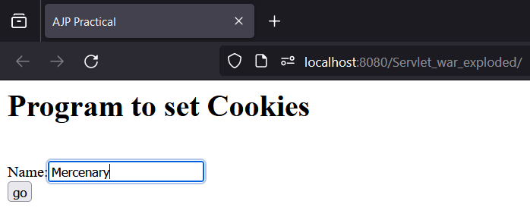

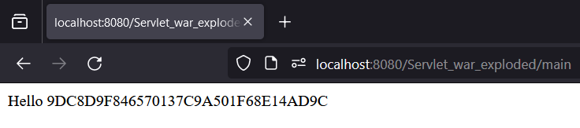

**2) Develop a program to collect user information using cookie.**

**CODE:**

**MainServlet:**

package ajp.servlet;   
import javax.servlet.annotation.WebServlet;  
import javax.servlet.http.*;  
import java.io.IOException;  
import java.io.PrintWriter;   
@WebServlet(name = "mainServlet", value = "/main")  
public class MainServlet extends HttpServlet {  
 public void doPost(HttpServletRequest request, HttpServletResponse response) throws IOException {  
 response.setContentType("text/html");  
 PrintWriter out = response.getWriter();  
 Cookie[] ck = request.getCookies();  
 out.print("Hello " + ck[0].getValue());  
 out.close();}}

**CodeServlet:**

package ajp.servlet;   
import javax.servlet.annotation.WebServlet;  
import javax.servlet.http.*;  
import java.io.IOException;  
import java.io.PrintWriter;   
@WebServlet("/login")  
public class CodeServlet extends HttpServlet {  
 public void doPost(HttpServletRequest request, HttpServletResponse response) throws IOException {  
 response.setContentType("text/html");  
 PrintWriter out = response.getWriter();  
 String n = request.getParameter("userName");  
 out.print("Welcome " + n);  
 Cookie ck = new Cookie("uname", n);  
 response.addCookie(ck);  
 out.print("<form action='CodeServlet'>");  
 out.print("<input type='submit' value='go'>");  
 out.print("</form>");  
 out.close();}}

**HTML:**<html>  
<head><title>AJP Practical</title></head>  
<body>  
<h1>Program to set Cookies</h1><br>  
<form action="main" method="post">  
 Name:<input type="text" name="userName"/><br/>  
 <input type="submit" value="go"/>  
</form>  
</body>  
</html>

**OUTPUT:**

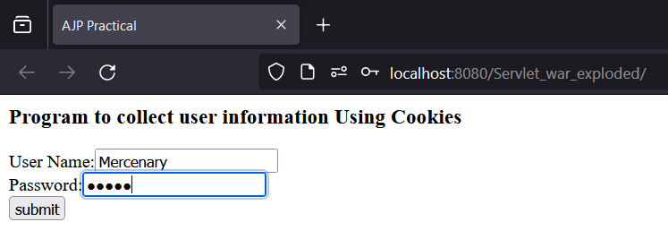

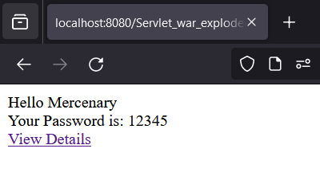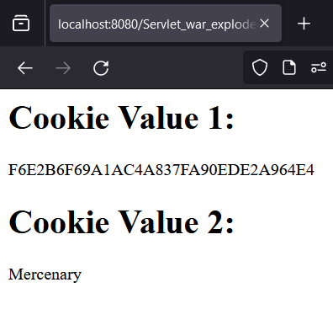

**3) Develop program to get the browser Information**

**CODE:**

**Servlet:**

package ajp.servlet;  
  
import javax.servlet.annotation.WebServlet;  
import javax.servlet.http.*;  
import java.io.IOException;  
import java.io.PrintWriter;  
  
@WebServlet("/code")  
public class CodeServlet extends HttpServlet {  
 public void doGet(HttpServletRequest request, HttpServletResponse response) throws IOException {  
 response.setContentType("text/html");  
 PrintWriter out = response.getWriter();  
 out.println("<html>");out.println("<head>");out.println("</head>");  
 out.println("<body><center>");out.println("<h1>");  
 out.println("Browser Details ");out.println("<br>");  
 out.println(" Character Encoding : " + request.getCharacterEncoding());  
 out.println("<br>");  
 out.println("Content Type : " + request.getContentType());  
 out.println("<br>");  
 out.println("Content Length: " + request.getContentLength());  
 out.println("<br>");  
 out.println("Protocol : " + request.getProtocol());  
 out.println("<br>");  
 out.println("Server Name : " + request.getServerName());  
 out.println("<br>");  
 out.println("Server Port : " + request.getServerPort());  
 out.println("<br>");  
 out.println("Remote Host : " + request.getRemoteHost());  
 out.println("<br>");  
 out.println("<br>");out.println("</h1>");  
 out.println("</center></body>"); out.println("</html>");  
 out.close();  
 }  
}

**OUTPUT:**

